

| **Name: Khan shoab akhat vakil ahamad** | **Course Name: SMA-LAB** |
| --- | --- |
| **Class: BE-CO** | **Batch: 01** |
| **Roll no: 19CO33** | **Experiment No: 03** |

**Aim:** Data Cleaning and Storage- Preprocess, filter and store social media data for business (Using Python, MongoDB, R, etc).

**Theory:** Social Media Scraping of Unilever using Python.

**1. Instagram:**

2. # Instagram

3. from instagramy import InstagramUser

4. user = InstagramUser("unilever")

5. print(f"Username: {user.fullname}")

6. print(f"Biography: {user.biography}")

7. print(f"Verified User: {user.is_verified}")

8. print(f"Website: {user.website}")

9. print(f"Followers: {user.number_of_followers}")

10.print(f"Following: {user.number_of_followings}")

11.print(f"No. Of Posts: {user.number_of_posts}")

12.posts = user.posts

13.print(posts[0])

14.instaPosts = []

15.for i in range(10):

16. post = {}

17. post["Likes"] = posts[i].likes

18. post["Comments"] = posts[i].comments

19. post["post_source"] = posts[i].post_source

20. post["post_url"] = posts[i].post_url

21. post["time"] = posts[i].taken_at_timestamp

22. instaPosts.append(post)

23.insta_df = pd.DataFrame(instaPosts)

24.insta_df.info()

25.print(insta_df.isna())

26.print(f"Latest posts:\n {insta_df}")

**OUTPUT :**

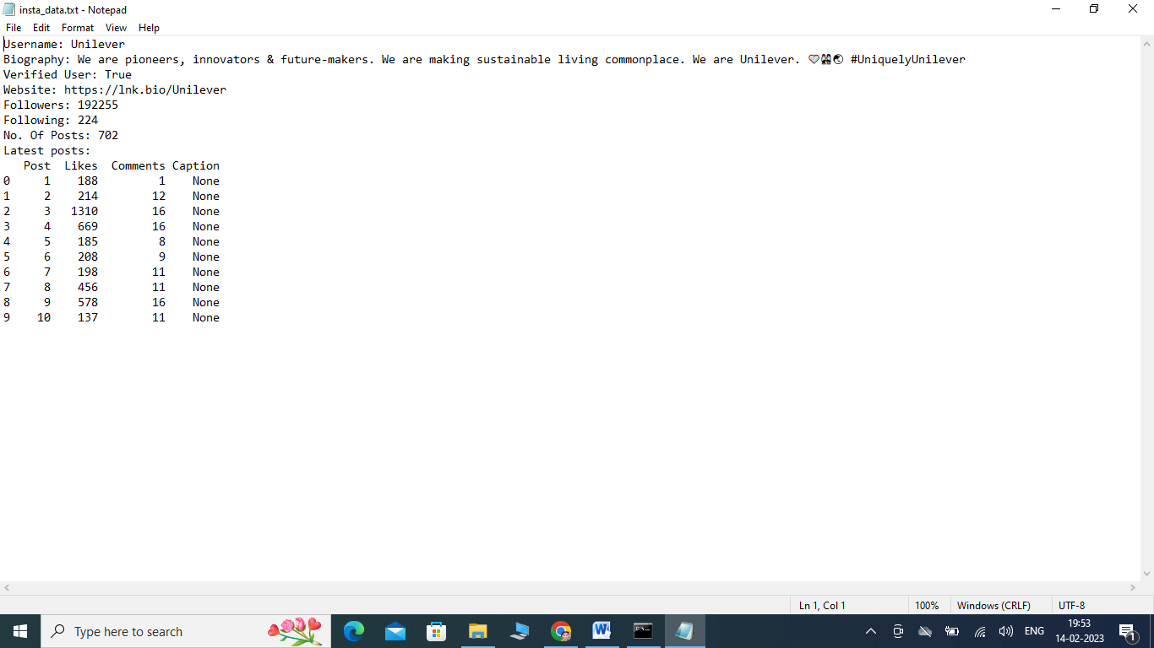

**2.Facebook:**

28.# Facebook

29.from facebook_scraper import get_posts

30.fbPosts = []

31.for post in get_posts('Unilever', pages=10):

32. fbPosts.append(post)

33.print(fbPosts)

34.df = pd.DataFrame(fbPosts)

35.df.info()

36.df = df[['post_id', 'text', 'post_url', 'page_id', 'comments', 'likes', 'time']]

37.print(df.isna())

38.print(print(f"Latest posts:\n {df}"))

**OUTPUT :** 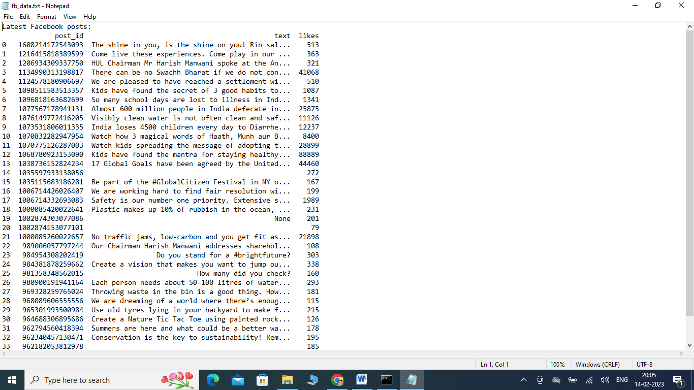

**3.Twitter:**

40.# Twitter

41.import twint

42.c = twint.Config()

43.c.Lang = "en"

44.c.Username = "Unilever"

45.c.Pandas = True

46.# Run

47.twint.run.Search(c)

48.Tweets_df = twint.storage.panda.Tweets_df

49.Tweets_df.info()

50.print(Tweets_df.isna())

51.Tweets_df = Tweets_df[Tweets_df.language == "en"]

52.Tweets_df = Tweets_df[['id', 'date', 'nlikes', 'language',

'nreplies','tweet', 'username']]

53.print(Tweets_df)

**Output :**

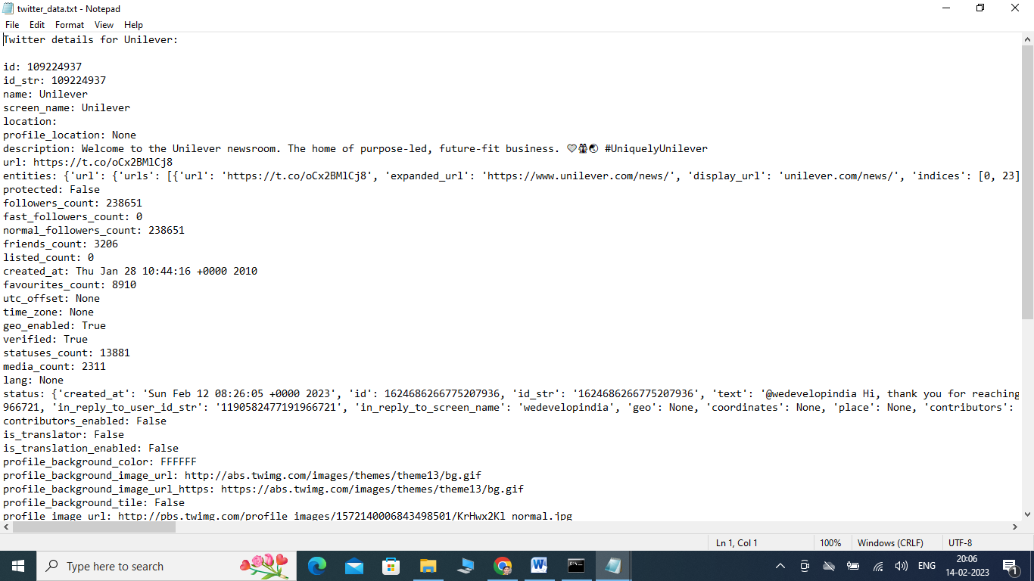

**Conclusion:** We have successfully cleaned Unilever’s social media data from websites like Instagram, Facebook, and Twitter using various data preprocessing techniques.